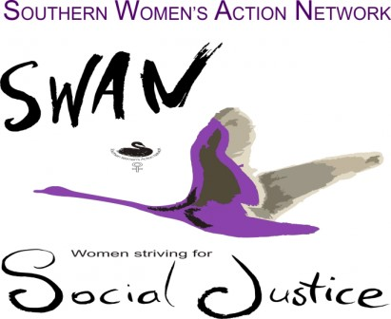
NOMINATION FORM 2021/2022
Please print clearly. Please consider whether you can offer your time for, typically, one Committee meeting every two months, your effort in putting forward your suggestions about events and direction and whatever other tasks you can take on.
Given the COVID restrictions, signatures will be considered received if the signatory emails the secretary indicating their agreement.

I NOMINATE _______________________________________________

FOR THE OFFICES AND/OR POSITION OF _________________________

__________________________________________________________
Offices /Positions are President (Facilitator), Secretary, Treasurer, Committee Member

___________________________ Signature _____________________
PERSON MAKING NOMINATION (Self nomination is encouraged)

___________________________ Signature______________________
SECONDER

I ACCEPT THIS NOMINATION Signature _____________________
PERSON NOMINATED

Completed forms should be posted to P.O. Box 392, Mt. MARTHA 3934 or emailed to the swanwomen@outlook.com.

